**Pracical No.:** 12

**Practical Title:**Create a web page for demonstration of CSS by applying Internal/External/Inline style

**Class: FYCM-I Batch: A Roll no: 15**

**Date:** 30th April 2022

**Code:**

<html>

<head>

<title> HOME </title>

<style>

.d1 {

width:100%;

padding:200px;

height:100px;

} **Output :**

.d2 {

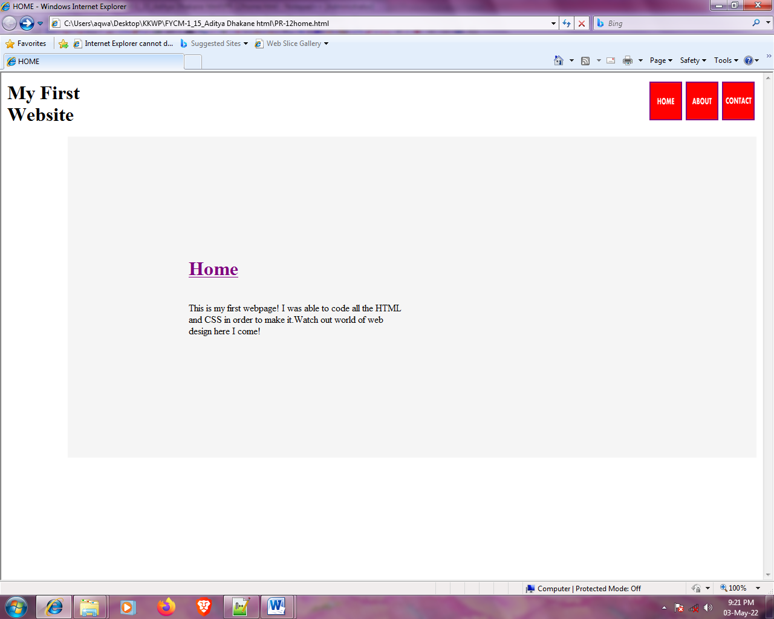background-color:whitesmoke;

width:100%;

padding:200px;

margin-left:100px;

}

.d1d1 {

width:200px;

height:100px;

text-align:left;

float:left;

margin:3px

}

.d1d2 {

width:500px;

height:200px;

float:right;

margin:3px

}

.sp {

width:500px;

height:200px;

padding:100px;

background-color:pink;

text-align:center:

float:right;

margin:5px

}

</style>

</head>

<body>

<a href="www.google.com">

<imgsrc="C:\Users\aqwa\Desktop\Contact.png" width="50" height="60" align="right" /><imgsrc="C:\Users\aqwa\Desktop\About.png" width="50" height="60" align="right" /><imgsrc="C:\Users\aqwa\Desktop\Home.png" width="50" height="60" align="right"/></a>

<b><p><h1>My First <br> Website</h1></b></p>

<div class="d2">

<ahref="www.google.com"><h1>Home</h1></a>

<br>This is my first webpage! I was able to code all the HTML

<br> and CSS in order to make it.Watch out world of web <br>

design here I come!

</div>

</body>

</html>